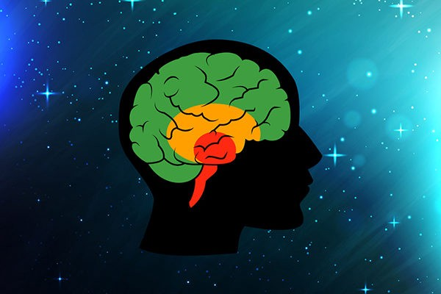

Limbic System – Monkey brain

Responding with emotion -

How you feel and behave are mixed together

**Brain Stem – Reptilian Brain**

**Responding with instinct -**

**Flight, Fright or Freeze**

**Cortex – Human Brain**

**Responding with thinking -**

**Feel, Stop, Think, Choose, Do**

**Which brain are you using?**